1. Game Description:

This will be a 2D game. This is simulating a medieval miner in a dark mine, only carrying a single torch, and your trusty pickaxe. You are trying to find gold ore to mine, while finding ways to get past or through blocked passages. You are trying to accomplish this, before your torch burns out.

• Chosen Game Category: Platformer

• Chosen Game Subcategory: Simulation

• Chosen Game Genre: Medieval

• Chosen Design Pattern: Observer

2. Game rules and conditions:  
• Objective of the game: You are trying to find gold ore to mine, while finding ways to get past blocked passages. You are trying to accomplish this, before your torch burns out.

• Rules of the game: You can mine gold ore or loose rock in front of the miner. You can jump up and down from platforms. You cannot move through platforms (solid rock). You are affected by gravity. You can only see a small radius around you (that is lit up by your torch).

• Win condition: Mine all the gold ore in the mine.

• Lose condition: The timer runs out (your torch burns out, and you get lost and die in the dark mine)

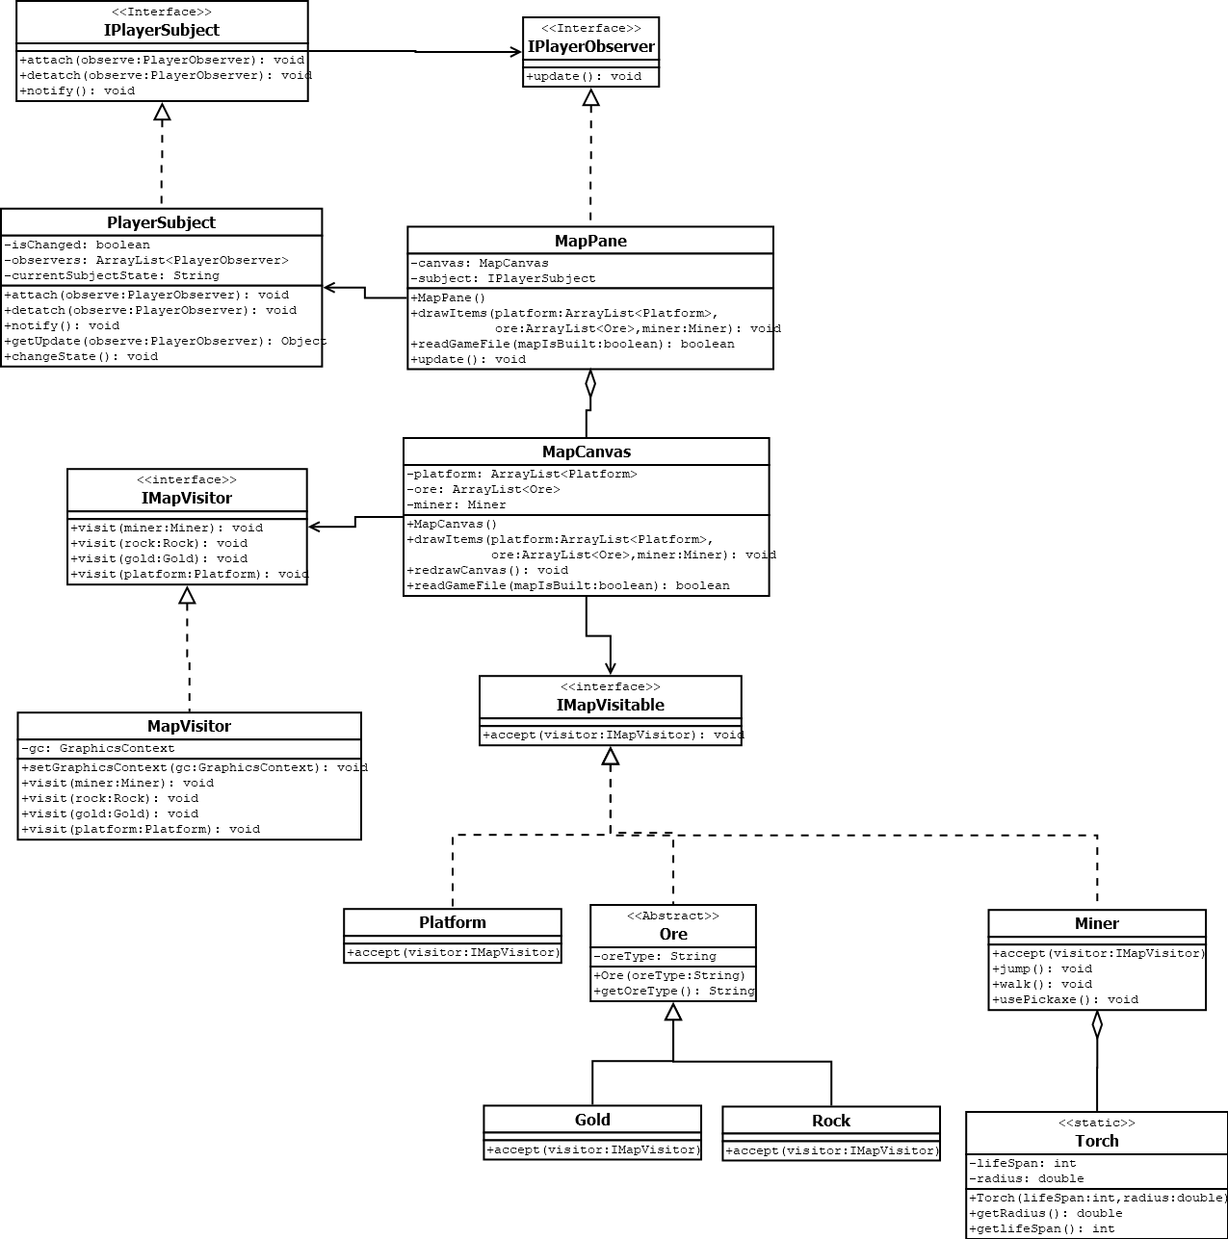

3.